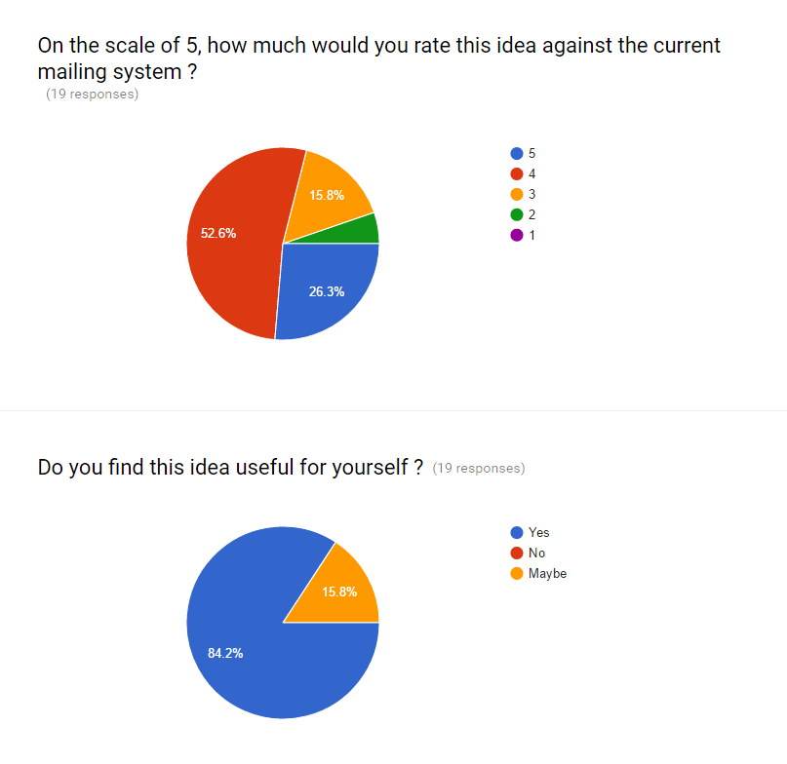

This feasibility study is for a Web-based application to share assessment results, resources, and methodologies on academic credential assessments.

We have taken responses from students in our university, for most of the people that is 84.2 % voted for our web portal and remaining 15.8% gave us some suggestion to improve our portal like our portal should be reliable and robust. Some said to have difference between portal and email system that is portal should be less time consuming. Some people suggested to make notification system efficient because every time it will be difficult to open Moodle to check for new posts.

Overall most of the people voted for our portal. a feasibility study aims to answer certain questions: 1. Does the system contribute to the overall objectives of the organisation?

2. Can it be implemented within current technology and within given cost and schedule constraints? 3. Can it be integrated with other systems that are already in place?

We have successfully collected reviews for all above questions. Hence our portal is feasible to proceed further.